**Paul Samuel S. Lacap**

(Written on November 16, 2022)

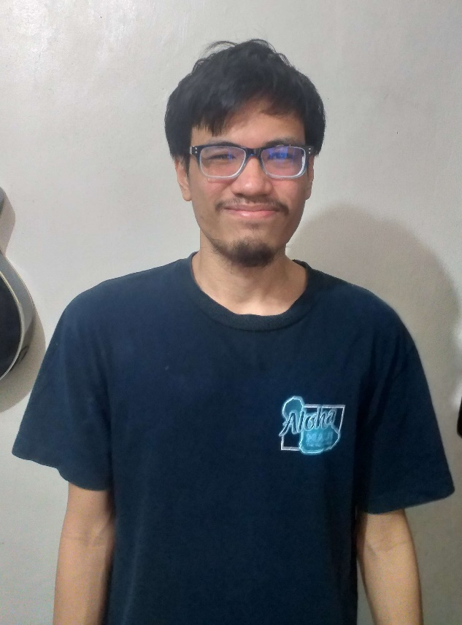

I was born in Manila however we moved to Laguna even before I gain sentience. As a kid in the 90’s, most of my childhood is spent playing outside. We play the usual *tagu-taguan*, *patintero*, *taya-tayaan*, and many others. But basketball was never really my thing. It’s like my body was not built for it. I enjoy badminton though as it is not as aggressive as basketball.

 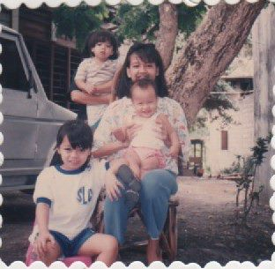 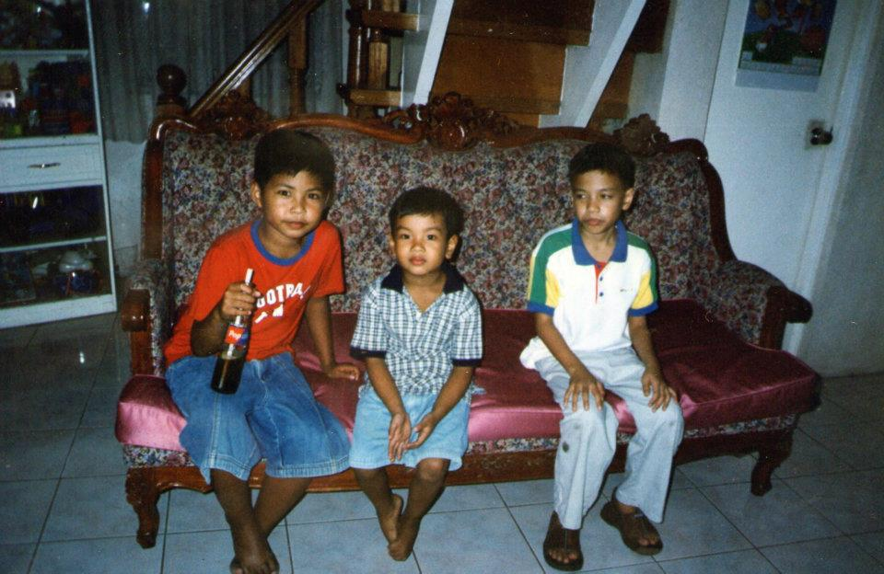

Note: I was the one starring at the soft drinks in the third picture 😊

I only went to one school in my elementary and high school days. It is named Emmanuel Christian School. The main reason why I did not change schools is due to the fact that the school is only half a day. Also, during high school is where I met where I can confidently say my long-term group of friends. It is because even now we are still catching up with each other. We have this group chat on FB wherein we connect with each other even though we have different lives and jobs now. They are also one of the main reasons why I did not change schools.

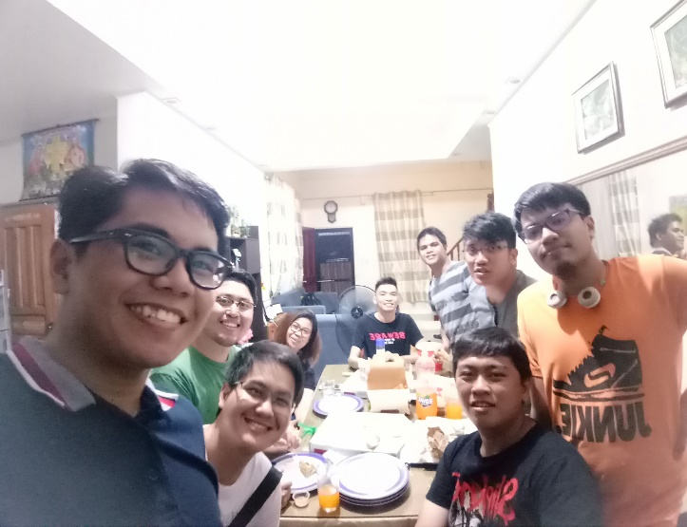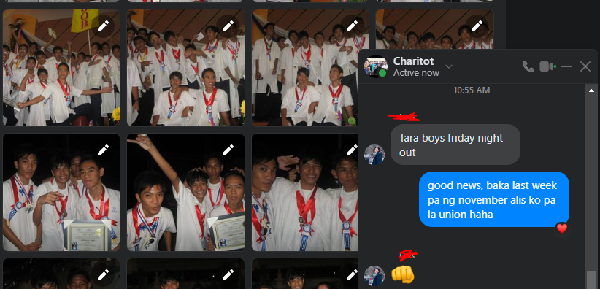

During high school, the video game Dota and League of Legends were really starting to become popular. We usually play LoL every Sunday after our Bible study session and we always jokingly said it was fellowship (haha).

It was also during this time that I started to dwell on my musical hobbies specifically the guitar. I started training for guitar in our church. It was also my first exposure to the instrument. The first song I played on guitar was… actually none because my fingers were not strong enough for the chords to even make a sound. It took me at least 2-4 weeks to master the guitar chords. Progressing slowly but consistently. Fast forward 2-3 years, and I am now positioned as a guitar 1 (lead guitarist) in our praise and worship team. I can’t fathom the pressure and nervousness I experienced during my first time in that spot. The church auditorium is air-conditioned but I am sweating a lot. I always have to remind myself I should not be the center of attention. But you are just an instrument used by God to help this congregation worshipping God to reduce my nervousness. Over time I managed to get the confidence to perform smoothly. But since I only performed in a church setup. I will still get really nervous if I need to perform in a secular setting. Since the audience will now be focusing on your performance.

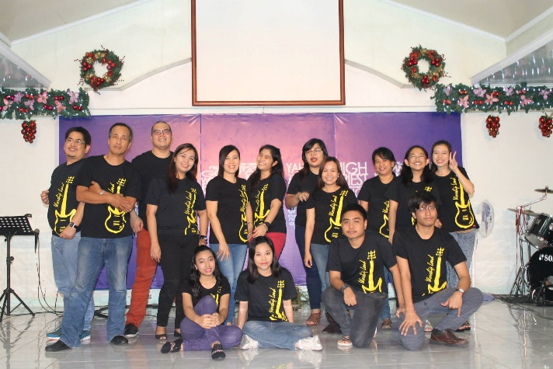 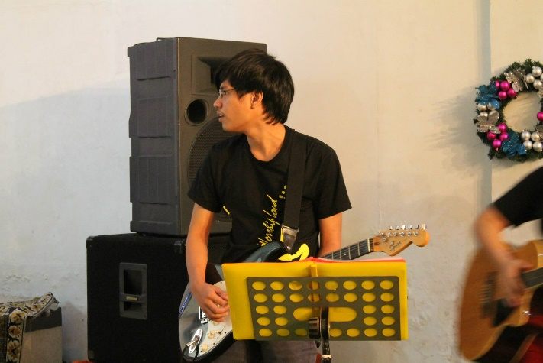

At college, I was fortunate enough to get accepted into the University of the Philippines. The degree I enrolled in is a BS in Applied Mathematics. However, I picked that course not because I really liked Math. I picked that course because I thought that I am not really one of the top students in school. Maybe if I picked this I can get through the quota since I know that it is not really a mainstream course. And fortunately, it worked! I enrolled in UP and boy it was a hard-fought battle to get my diploma. I always felt like the underdog since some of my classmates came from really prestigious science high schools. Some were valedictorians, and others were people who join quiz competitions in high school. Meanwhile, I’m just a normal student that did not even graduate as a dean’s lister in high school. But it was at UP that I learned how to learn. It was the time wherein I really started taking studying seriously just to catch up with the lessons. Because I really felt that if I did not take this seriously. I will fail the class.

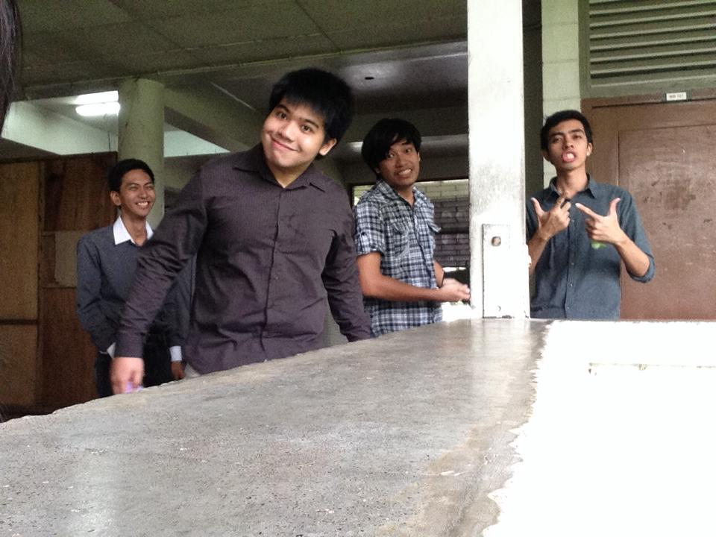 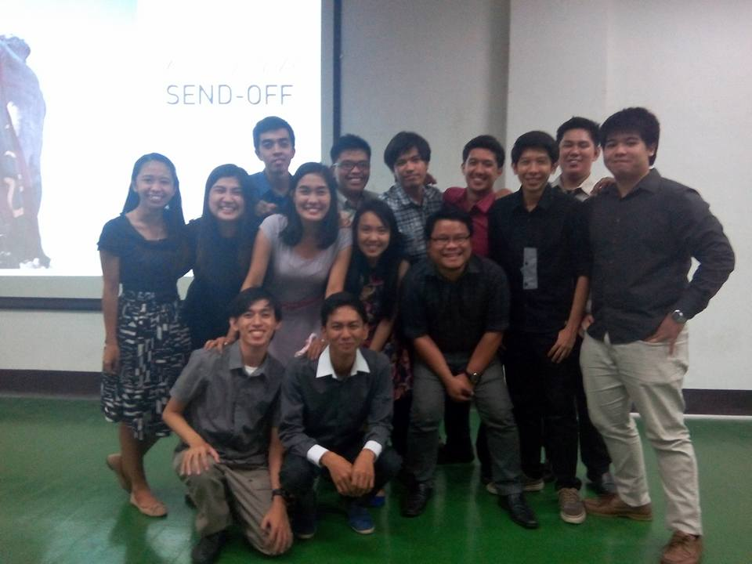

The above pics are a picture of me in college and my batchmates 😊

During my 2nd year in college, I played this little indie game called “To The Moon”. It was in an external hard drive my friend lent to me. It was a simple game, with pixelated graphics, it looks like something a one-man dev can do. But it was an amazing experience. The way how the graphics, the soundtrack, and the storytelling blended together to elevate the game is really astounding. Then in my mind I thought, I wanted to do something similar. A game that can really make the player feel the same way I felt. However, I have no programming experience and my goal at that point is just to really graduate college as soon as possible. I did not entertain shifting my college course. But I know the seed for my passion for programming was planted at that point.

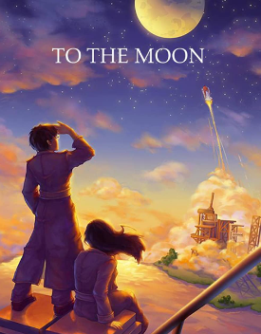 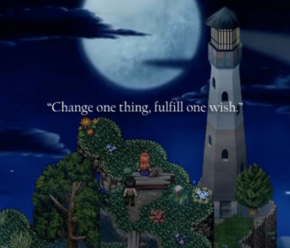

After college, I managed to get a job as an actuary. My role is to protect the financial stability of the company by doing risk analysis. During my first weeks as exposure to the actuarial world. I realized that my heart is not in this career. The seed that was planted in me about programming and game development just kept growing. That’s when I decided to pursue it. I said to myself 8+ hours of my daily life are being spent at work. I might as well spend it on something that I am truly passionate about. Every night after work I turn on my laptop and started learning game development. I started with a Udemy course on Unity. It was a really good course and I learned a lot. I managed to elevate my Unity game development skill to the point that I can now make any 2D game mechanic I want. My problem was the efficiency of my code. Since I have no knowledge of the fundamentals of Computer science my code structure is not really good. I can make the game work but my codes were far from elegant.

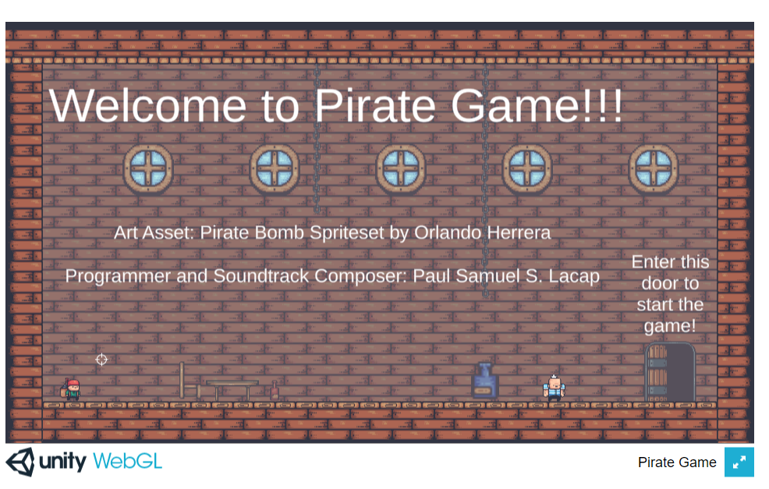

You can try my game here 😊: <https://psl012.github.io/PirateGame/>

That’s when I decided to go back to school to learn computer science. However, after 2 semesters I decided to stop enrolling. The first reason is I no longer want to burden my parents financially (they were the ones paying for my tuition). The second reason is I realized I don’t need the degree, I just need the learnings. I found out there were lots of free resources on the internet about computer science. I mainly focused on the OSSU GitHub repository. It is a collection of free MOOCS about computer science. I spent at most three years studying its core courses while also searching for myself on what I really want to do in life. I decided to put my game development as just a hobby and pursue full-stack development as a career. That’s when I saw a post by Village88 providing free training. I researched about it and upon finding out that it’s legit, especially knowing about Coding Dojo. I enrolled and worked really hard to finish the training. I greatly admired sir Michael Choi’s vision of making San Fernando the Philippines’ version of Silicon Valley and thus the reason I applied and now I am here. No longer as a trainee but as a villager 😊.